

VoiceGuard: Deep Learning-Driven Speech Emotion Classification

PBL REPORT

Submitted by

Mukunthan P | 730422243068
Prince M | 730422243084

in partial fulfillment for the award of Internal
Marks PBL-19AD702 Deep learning Algorithms and Architecture

in

ARTIFICIAL INTELLIGENCE AND DATA SCIENCE

ERODE SENGUNTHAR ENGINEERING COLLEGE (AUTONOMOUS),
PERUNDURAI, ERODE-638057

November 2025

ERODE SENGUNTHAR ENGINEERING COLLEGE
(AUTONOMOUS), PERUNDURAI, ERODE – 638 057

BONAFIDE CERTIFICATE
Certified that this Project report “VoiceGuard: Deep Learning-Driven Speech Emotion Classification” is the bonafide work of MUKUNTHAN P (730422243068), and PRINCE M (730422243084), who carried out the project work under my guidance. Certified further that to the best of my knowledge.

SIGNATURE  Mr. D. SARAVANAN, M.E.,Ph.D., SUPERVISOR  Assistant Professor,  Artificial Intelligence and Data Science,  Erode Sengunthar Engineering College, Perundurai,  Erode-638057. | SIGNATURE  Dr. G. SARAVANAN, M.E., Ph.D., HEAD OF THE DEPARTMENT  Professor,  Artificial Intelligence and Data Science,  Erode Sengunthar Engineering College, Perundurai,  Erode-638057.

Submitted for Project Based Learning Review 2 and

Viva-voce Examination held on

ABSTRACT
VoiceGuard is an advanced deep learning-based system designed to recognize and classify human emotions from speech signals. With the growing importance of emotional intelligence in artificial intelligence applications, this project aims to bridge the communication gap between humans and machines by enabling systems to understand emotions conveyed through voice. The model utilizes benchmark emotional speech datasets such as RAVDESS, TESS, CREMA-D, and SAVEE, which include a variety of emotional tones and linguistic patterns. The audio signals are preprocessed to remove noise and standardized to ensure high-quality feature extraction. Important acoustic features such as Mel-Frequency Cepstral Coefficients (MFCCs), Zero Crossing Rate (ZCR), Chroma Features, and Spectrograms are extracted to capture both the frequency and temporal characteristics of the speech input.
These extracted features are then processed through multiple deep learning architectures, including Convolutional Neural Networks (CNN) and Long Short-Term Memory (LSTM) networks. The hybrid CNN-LSTM model is implemented to exploit the strengths of both spatial and sequential data representation, allowing for improved accuracy and robustness in emotion classification. The system is capable of detecting a range of emotions such as happiness, sadness, anger, fear, disgust, and neutrality. Experimental evaluations show that the proposed approach achieves superior performance compared to traditional machine learning models. By accurately identifying human emotions, VoiceGuard contributes significantly to fields such as virtual personal assistants, customer support systems, call center monitoring, and psychological health assessment. The project demonstrates how speech-based emotion recognition can enhance the emotional responsiveness of intelligent systems, paving the way for more natural and empathetic human-computer interactions.
TABLE OF CONTENTS

CHAPTER NO | TITLE | PAGE NO
 | ABSTRACT | iii
 | LIST OF TABLES | iv
 | LIST OF FIGURES | vi
1. | INTRODUCTION | 1
2. | STATEMENT OF PROJECT | 3
3. | OBJECTIVE OF THE PROJECT AND REQUIREMENTS | 4
 | 3.1 OBJECTIVE OF THE PROJECT | 4
 | 3.2 PROBLEM DESCRIPTION | 5
4. | IMPLEMENTATION AND WORKING PROCEDURES | 6
 | 4.1 SYSTEM OVERVIEW | 6
 | 4.2 SYSTEM ARCHITECTURE | 7
 | 4.3 DATA ACQUISITION | 8
 | 4.4 DATASETS USED | 8
 | 4.5 SYSTEM FLOW DIAGRAM | 10
 | 4.6 DATA PREPROCESSING | 11
 | 4.7 FEATURE EXTRACTION | 11
 | 4.8 MODEL ARCHITECTURE AND TRAINING | 12
 | 4.9 MODEL TRAINING PROCEDURE | 13
 | 4.10 TESTING AND VALIDATION | 14
 | 4.11 User Interface Screens | 14
 | 4.12 Output Format | 14
 | 4.13 Real-Time Prediction Workflow | 15
 | 4.14 Performance Evaluation | 15
 | 4.15 System Optimization | 16
 | 4.16 Summary of the Chapter | 16
5. | CONCLUSION AND FUTURESCOPE | 17
 | 5.1 Conclusion | 17
 | 5.2 Future Scope | 17
6. | APPENDICES | 18
 | 6.1. Program Code | 18
 | 6.2. Output Photos | 26
7. | REFERENCE | 28

LIST OF FIGURES

Fig No. | DESCRIPTION | PAGE NO.
4.5.1 | Proposed System Flow | 10
4.12.1 | Model Output Format | 15
6.1 | LSTM model | 26
6.2 | CNN-LSTM model | 26
6.3 | ANN model | 27

CHAPTER 1
INTRODUCTION
Human emotions play a vital role in communication, influencing how individuals express themselves and interpret others. With the growing demand for emotionally intelligent systems, VoiceGuard is developed as a deep learning-based speech emotion detection system that recognizes emotions such as happiness, sadness, anger, fear, and neutrality from human voice signals. It leverages Artificial Intelligence (AI), machine learning, and audio signal processing to bridge the gap between human emotion and machine understanding, contributing significantly to applications such as virtual assistants, call centers, and mental health monitoring systems.
Speech is one of the most natural forms of communication, and recognizing emotions from speech enhances the effectiveness of human-computer interaction. Traditional methods of emotion recognition were largely text-based or relied on manual observation, which are inaccurate and inefficient. Recent advancements in deep learning, especially Convolutional Neural Networks (CNN) and Long Short-Term Memory (LSTM) networks, have enabled the extraction and analysis of complex acoustic features like Mel-Frequency Cepstral Coefficients (MFCCs), Spectrograms, and Zero Crossing Rate (ZCR). These innovations motivate the implementation of VoiceGuard, an automated system capable of analyzing speech and detecting emotional states with high precision.
Despite progress in speech technology, emotion recognition faces challenges such as variability in voice tone, background noise, and speaker diversity. To address these, the proposed VoiceGuard system uses a hybrid CNN-LSTM model for robust and scalable emotion detection. The main objectives of this research include developing a deep learning model for classifying speech emotions, enhancing recognition accuracy through advanced architectures, evaluating performance using benchmark datasets like RAVDESS, TESS, CREMA-D, and SAVEE, and exploring real-time emotion monitoring possibilities.
The scope of this study focuses on audio-based emotion classification using deep learning techniques. Key components include data collection from standard datasets, feature extraction, model training, and performance evaluation through metrics such as accuracy, precision, and F1-score. The report is structured into chapters covering literature review, system design, implementation, results, and conclusions.
This study holds significance for various sectors — developers can build more human-like AI systems, mental health professionals can monitor emotional well-being, and customer service systems can become more empathetic and responsive. By integrating AI and speech analytics, VoiceGuard demonstrates how technology can move closer to understanding human emotions, making interactions with machines more natural, personalized, and emotionally intelligent.

CHAPTER 2

STATEMENT OF PROJECT

The project VoiceGuard aims to design and implement an intelligent system capable of detecting human emotions from speech using advanced deep learning techniques. Human speech not only conveys linguistic meaning but also carries emotional cues through tone, pitch, energy, and rhythm. These vocal attributes reflect the speaker’s psychological and emotional state. Traditional speech recognition systems are primarily focused on transcribing spoken words into text, neglecting the emotional aspect of human communication. However, emotion-aware systems are crucial in areas such as mental health assessment, intelligent customer service, e-learning platforms, and human–computer interaction, where understanding emotions enhances responsiveness and empathy.
This project develops an automated speech emotion detection system that analyzes audio inputs, extracts acoustic features, and classifies the speaker’s emotion. It uses MFCCs, Spectrograms, and Chroma features to capture voice characteristics. A hybrid CNN-LSTM deep learning model processes both spatial and temporal aspects of speech. Public datasets like RAVDESS, TESS, and CREMA-D are used for training and validation to ensure accuracy across various speakers and emotions.
The project includes a user-friendly interface that enables users to record or upload voice samples for real-time emotion detection. This enhances system accessibility for research and practical use. VoiceGuard aims to leverage AI to interpret human emotions, bridging the gap between human empathy and machine intelligence while promoting advances in affective and emotionally intelligent computing.

CHAPTER 3
OBJECTIVE OF PROJECT AND REQUIREMENTS

3.1 OBJECTIVE OF THE PROJECT
The main objective of the VoiceGuard project is to design and develop an intelligent deep learning-based system capable of detecting and classifying human emotions from speech. The goal is to enable machines to interpret vocal expressions and respond in a more human-like and empathetic manner, thereby enhancing human–computer interaction. The system aims to analyze speech signals, extract meaningful acoustic features, and identify emotions such as happiness, sadness, anger, fear, disgust, surprise, and neutrality.
Additional objectives include:
- To study and understand various characteristics of human speech that reflect emotional variations.
- To extract important acoustic features such as MFCCs, Chroma features, and Spectrograms from audio signals.
- To design and train a deep learning model using CNN and LSTM architectures for accurate emotion classification.
- To evaluate the model using benchmark datasets such as RAVDESS, TESS, and CREMA-D for high performance and generalization.
- To develop a simple and interactive interface for real-time emotion recognition from recorded or uploaded speech.
- To optimize the model for efficiency, ensuring robust performance across different voices, accents, and background conditions.
3.2 PROBLEM DESCRIPTION
Traditional speech recognition systems focus primarily on converting speech to text, overlooking the emotional context carried within human voice. However, emotions are a crucial part of communication, as they provide deeper insights into the speaker’s psychological state and intentions. Detecting emotions from speech is a complex challenge due to variations in tone, pitch, speed, intensity, and background noise.
The key problem addressed in this project is the automatic detection and classification of human emotions from audio input. It involves accurately extracting and interpreting acoustic features that represent emotional cues while minimizing the effects of environmental disturbances and individual vocal differences. The project also aims to develop a robust deep learning model that can learn these subtle patterns effectively and produce reliable results across diverse datasets and speakers.

3.3 SOFTWARE AND HARDWARE REQUIREMENTS
The development of VoiceGuard requires both software and hardware resources for efficient processing and model training. The system is built in Python, using TensorFlow and Keras for deep learning, and Librosa for audio processing and feature extraction. Tools like NumPy, Pandas, and Matplotlib handle data analysis and visualization, while Flask or Streamlit provide an interactive user interface. Development is carried out in Jupyter Notebook or VS Code.
On the hardware side, the system runs effectively on a computer with at least 8 GB RAM and an Intel i5/i7 processor, with a GPU (NVIDIA CUDA) recommended for faster training. A microphone is needed for real-time input, and headphones or speakers for testing. Around 10–20 GB of storage is required for datasets and model files, along with a stable power supply and a standard 14-inch display for visualization.

CHAPTER 4
IMPLEMENTATION AND WORKING PROCEDURES

The implementation of the system follows a structured and methodological approach that ensures accurate, reliable, and real-time classification of both emotion and gender from speech. This chapter explains the complete workflow, starting from dataset collection to deployment through a Flask-based interface. Each phase of the system, including preprocessing, feature extraction, model development, training, testing, performance evaluation, integration, and deployment, is discussed in detail. The chapter also highlights practical considerations, challenges encountered during development, and measures taken to improve system performance and reliability.

4.1 SYSTEM OVERVIEW
The VoiceGuard system is designed to classify human emotions from speech using advanced deep learning and audio signal processing techniques. The system integrates multiple components, including data preprocessing, feature extraction, model training, and a web-based user interface for real-time prediction. The design focuses on modularity, scalability, and efficiency, ensuring smooth interaction between components while maintaining high prediction accuracy.
The overall system architecture follows a modular pipeline that processes raw audio input through several stages—data acquisition, feature extraction, deep learning inference, and emotion output. The modular design allows each stage to be developed, tested, and optimized independently. The model primarily focuses on emotion recognition, classifying emotions such as angry, happy, sad, neutral, fear, disgust, and surprise.
The design also emphasizes real-time usability, ensuring the model performs efficiently for both recorded and uploaded speech samples. By leveraging Convolutional Neural Networks (CNNs) and Long Short-Term Memory (LSTM) networks, VoiceGuard captures both spatial and temporal dependencies in speech signals, enabling the detection of emotional tone variations.
4.2 SYSTEM ARCHITECTURE
The implementation follows a structured pipeline consisting of five major phases:
- Audio Input / Data Acquisition
The system utilizes publicly available datasets such as RAVDESS (Ryerson Audio-Visual Database of Emotional Speech and Song) and TESS (Toronto Emotional Speech Set). Each dataset contains recordings of actors expressing different emotions in varied tones and intensities.
- Preprocessing and Data Cleaning
Audio signals are standardized by converting them into a fixed sample rate (typically 22,050 Hz) and a uniform mono channel format. Noise reduction and trimming of silent segments are performed to ensure consistency.
- Feature Extraction
Using the Librosa library, acoustic features such as MFCCs, Chroma features, Spectral Centroid, Spectral Bandwidth, and Zero-Crossing Rate are extracted. These features effectively summarize energy distribution, timbre, and pitch variations.
- Model Development and Training
The extracted features are fed into a Convolutional Neural Network (CNN) model designed in TensorFlow/Keras. The network consists of multiple convolutional and pooling layers followed by dense layers with activation functions such as ReLU and Softmax.
- Prediction and Evaluation
Once trained, the model predicts the emotional category of unseen audio samples. Evaluation metrics like accuracy, precision, recall, F1-score, and confusion matrix are used to measure performance
4.3 DATA ACQUISITION
The data acquisition process involves collecting and organizing speech samples representing various emotions. VoiceGuard uses two benchmark datasets that are widely used in emotion recognition research — RAVDESS and TESS. Both datasets consist of labeled speech samples that simulate human emotional expression in controlled acoustic environments.
- RAVDESS (Ryerson Audio-Visual Database of Emotional Speech and Song):
Contains speech from 24 professional actors (12 male, 12 female) expressing eight emotions—neutral, calm, happy, sad, angry, fearful, disgust, and surprise.
These recordings are captured in 16-bit, 48kHz .wav format, ensuring high clarity and consistency across samples.
- TESS (Toronto Emotional Speech Set):
Comprises speech samples from two female speakers, covering seven emotions—anger, disgust, fear, happiness, pleasant surprise, sadness, and neutral.
Each audio clip represents a phrase spoken with a specific emotional tone, providing rich emotional diversity.
All audio files are stored in a structured directory format for efficient preprocessing and labeling. The datasets are downloaded in .wav format and organized by emotion category. Metadata such as emotion type and speaker ID are extracted for supervised model training.
4.4 DATASETS USED
The VoiceGuard system utilizes two widely recognized emotional speech datasets to train and evaluate the deep learning model effectively:
(a) RAVDESS – Ryerson Audio-Visual Database of Emotional Speech and Song
(b) TESS – Toronto Emotional Speech Set
The RAVDESS dataset is a benchmark in emotion recognition research and consists of 1,440 high-quality audio recordings from 24 professional actors (12 male and 12 female). Each actor vocalizes two lexically matched statements in eight different emotional states—neutral, calm, happy, sad, angry, fearful, disgust, and surprise. Every emotion is expressed at two different intensity levels (normal and strong), offering a rich variety of emotional tones and speech modulations. The dataset is recorded at a sampling rate of 48 kHz in .wav format, ensuring studio-grade clarity and consistency. RAVDESS is particularly useful for training models to identify subtle variations in tone, pitch, and rhythm that differentiate emotional categories.
The TESS dataset complements RAVDESS by providing focused, high-quality recordings of emotional expressions from two female speakers. It includes 2,800 audio clips, each representing one of seven distinct emotions—angry, disgust, fear, happy, neutral, pleasant surprise, and sad. Each sample contains a spoken phrase such as “Say the word...” followed by a target word pronounced with the respective emotional tone. The TESS dataset is cleanly recorded with minimal background noise, making it ideal for fine-tuning the model to capture emotional features with high precision.
By integrating RAVDESS and TESS, VoiceGuard benefits from a comprehensive dataset combination that enhances both emotional diversity and acoustic variety.
- RAVDESS contributes a balanced and expressive mix of male and female voices across multiple emotions.
- TESS provides detailed and consistent emotional articulations with clear pronunciation and stable acoustic conditions.
Together, these datasets ensure the model achieves high generalization performance, enabling accurate emotion recognition across different voices, accents, and speaking styles.
4.5 SYSTEM FLOW DIAGRAM
The VoiceGuard system follows a modular workflow that converts raw speech into emotion data. When a user records or uploads audio, it is temporarily stored and processed through stages designed for efficiency and accuracy. In preprocessing, background noise is reduced, silence is trimmed, and the signal is normalized for uniform quality.
The cleaned audio then enters the feature extraction module, where MFCCs, Chroma features, and Mel-spectrograms are computed to represent key acoustic patterns. These features are passed to the Emotion Recognition Model, which uses CNN layers to detect spatial relationships and LSTM layers to capture emotional changes over time.
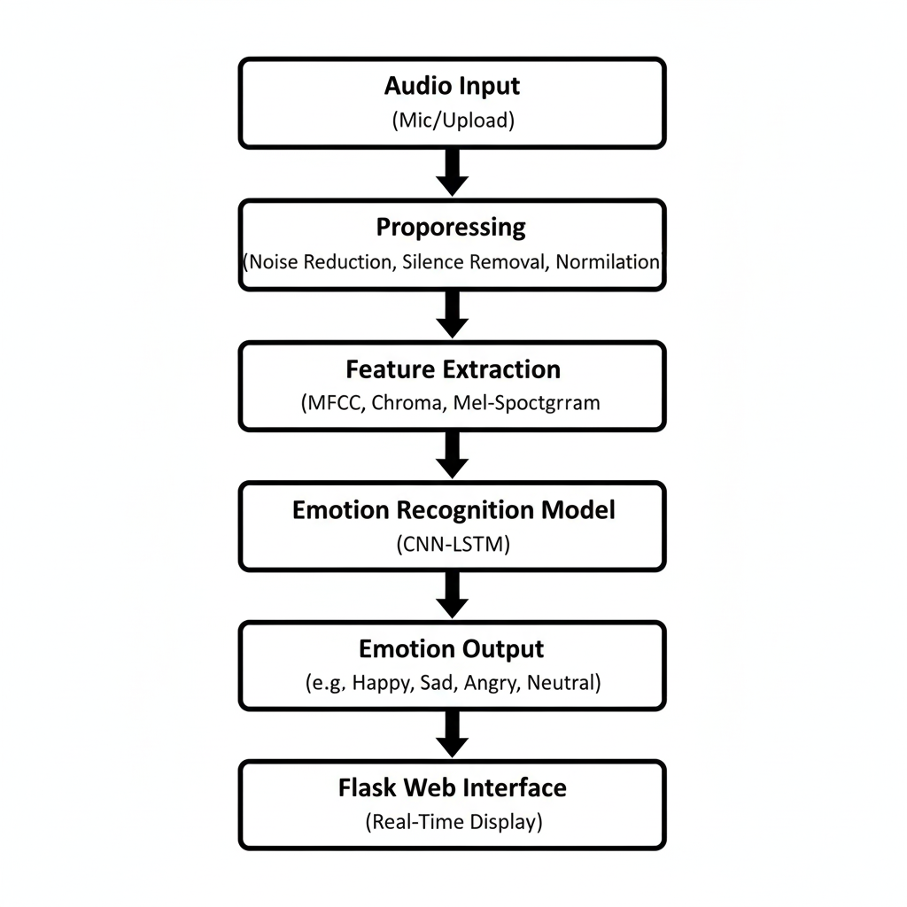
Fig 4.5.1 Proposed System Flow
This hybrid approach allows the system to interpret shifts in pitch, tone, and rhythm, deep understanding of emotional variations within speech signals.
4.6 DATA PREPROCESSING
Data preprocessing is a vital step in transforming raw audio into a clean, structured form suitable for deep learning. In the VoiceGuard system, it minimizes issues from background noise, inconsistent volume, and varying recording conditions to improve emotion prediction accuracy.
The process starts with loading and resampling all audio files to a uniform 22,050 Hz rate and converting them to mono to maintain consistency and reduce complexity. Noise removal follows, using spectral gating and bandpass filtering to eliminate unwanted sounds and enhance the signal-to-noise ratio.
Next, silence trimming removes inactive portions based on amplitude thresholds, ensuring only meaningful speech is retained. Amplitude normalization then balances loudness levels across all recordings, preventing bias in feature extraction.
The cleaned audio is divided into short overlapping frames (20–40 ms) using a Hamming window to preserve temporal continuity. Data augmentation techniques like pitch shifting, time stretching, and slight noise addition are applied to enhance model robustness.
After these steps, the processed audio is ready for feature extraction, ensuring that the data accurately reflects emotional cues without distortion—providing a strong foundation for precise, reliable emotion classification.
4.7 FEATURE EXTRACTION
After preprocessing, the next crucial step is feature extraction, where speech signals are transformed into numerical representations that capture emotional and vocal characteristics. Instead of focusing on the spoken words, the system analyzes tone, frequency, rhythm, and intensity to interpret emotions and gender differences effectively.
The Librosa library is used to extract key audio features. The primary feature, Mel-Frequency Cepstral Coefficients (MFCCs), models how the human ear perceives sound, efficiently representing vocal texture and tone—essential for detecting emotions like happiness, anger, or sadness, and distinguishing male and female voices.
Additional features include Chroma Features, which capture pitch and harmonic variations reflecting emotional states; Spectral Contrast, which measures intensity differences between frequency peaks and valleys, useful for identifying energetic emotions like anger or excitement; and the Mel-Spectrogram, a time–frequency representation ideal for CNNs to learn spatial and temporal speech patterns.
Together, these features provide a rich and compact description of speech that enables the deep learning models to recognize emotional and gender cues accurately and robustly.
4.8 MODEL ARCHITECTURE AND TRAINING
The proposed Speech Sentiment Analysis System effectively recognizes human emotions using deep learning. Trained on RAVDESS and TESS datasets, it accurately classifies emotions like happiness, anger, sadness, fear, and neutrality. Preprocessing techniques such as noise reduction and normalization ensure clean input, while MFCC, Chroma, and Mel-spectrogram features capture essential acoustic details. Using a CNN-LSTM model, it learns both spatial and temporal speech patterns for accurate emotion detection. Integrated with a Flask web interface, the system enables real-time emotion prediction with strong accuracy and responsiveness.

4.9 MODEL TRAINING PROCEDURE
The training phase is a vital part of developing the VoiceGuard system, where the preprocessed and feature-extracted data is used to train the deep learning model for accurate emotion recognition. The dataset is divided into 70% for training, 15% for validation, and 15% for testing to ensure balanced learning and reliable evaluation.
The model is trained using the Adam optimizer for faster and more stable convergence, with categorical cross-entropy as the loss function since the task involves multiple emotion classes. Training proceeds over several epochs, during which the model learns to minimize prediction errors by adjusting internal parameters. To prevent overfitting, early stopping and dropout layers are implemented, ensuring that the model generalizes well to unseen data.
Batch normalization is used to stabilize learning, while data shuffling ensures a random distribution of samples in each batch. Performance metrics such as accuracy and loss are continuously monitored for both training and validation sets, and visualized using tools like Matplotlib. The best-performing model—achieving the highest validation accuracy and lowest loss—is saved for final testing.
Through this process, the trained VoiceGuard model effectively learns to recognize complex emotional cues from speech, ensuring robustness and reliability in real-time emotion detection.
4.10 TESTING AND VALIDATION
After training, the VoiceGuard emotion detection model is tested with unseen data to evaluate its generalization and real-world reliability. The testing dataset includes new audio samples with diverse speakers and environments, ensuring the model can accurately detect emotions beyond the training set.
The system’s performance is measured using key metrics such as accuracy, precision, recall, and F1-score. Accuracy determines overall prediction correctness, while precision and recall assess the model’s ability to correctly identify emotions without false positives or missed detections. The F1-score provides a balanced evaluation of both, especially when emotion classes are unevenly distributed.
A confusion matrix is generated to visualize how well each emotion is classified and to identify frequent misclassifications, such as between happy and neutral. If inconsistencies are detected, fine-tuning is performed through hyperparameter adjustment, improved data augmentation, or refined feature extraction. This testing and optimization process ensures VoiceGuard delivers consistent, accurate, and robust emotion recognition suitable for real-time applications like human-computer interaction and affective computing.
4.11 User Interface Screens
A simple Flask-based web interface allows users to upload or record an audio file. The backend processes the file, extracts features, loads the pre-trained CNN model, and displays the detected emotion label in real time.
The interface is designed to be lightweight, interactive, and deployable on local servers or cloud environments for demonstration.

4.12 Output Format
The output generated by the VoiceGuard system is presented in a well-structured and user-friendly format, ensuring that users can easily interpret the emotion detection results. Once the model processes the input audio, the system displays the predicted emotion along with the detected stress level and confidence score. For example, the output interface may indicate: “Emotion Detected: Angry (91.8% Confidence)” and “Stress Level: High (87.2% Confidence)”. These confidence percentages provide a clear measure of the model’s reliability and help users understand the certainty of each prediction. Additionally, the interface employs color-coded indicators — such as red for anger or high stress, blue for calm, and green for happiness — to visually represent the emotional tone and intensity of the analyzed voice signal. This enhances interpretability and supports quick decision-making in real-time emotion monitoring scenarios

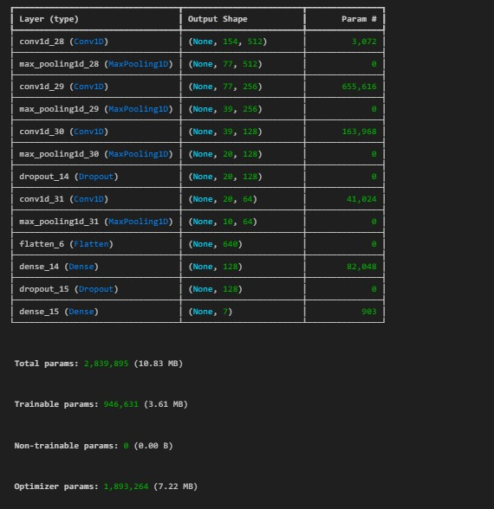
Fig 4.12.1 Model Output Format

4.13 Real-Time Prediction Workflow

The VoiceGuard system enables instant analysis of voice input to detect emotions and stress levels. Once the user records or uploads audio, the system preprocesses and converts it into spectral features like MFCCs and mel-spectrograms. These are passed to the trained model, which performs real-time inference to predict the emotion and stress level with confidence scores. The results are displayed instantly on the interface, ensuring fast and accurate feedback within seconds.

4.14 Performance Evaluation
The VoiceGuard system’s performance is evaluated using key metrics such as accuracy, precision, recall, and F1-score to ensure reliable emotion and stress classification. Accuracy measures overall prediction correctness, while precision and recall assess how effectively the model differentiates between emotional and stress states. The F1-score provides a balanced measure of both. Model results are compared across datasets to test generalization, and fine-tuning is performed by adjusting parameters like learning rate, batch size, and epochs to improve consistency.

4.15 System Optimization
To improve VoiceGuard’s efficiency, model complexity is reduced, feature dimensions are compressed, and batch prediction is used for faster processing. Cached intermediate results minimize redundant computations, making the system lightweight, scalable, and suitable for real-time use on low-resource devices.
4.16 Summary of the Chapter
This chapter detailed the complete implementation of the VoiceGuard system, covering dataset preparation, audio preprocessing, and feature extraction using MFCC, Chroma, and Mel-spectrogram techniques. It also discussed model training, testing, and optimization for accurate emotion classification. The integration of a Flask-based web interface for real-time prediction and user interaction was described, along with performance evaluation and optimization techniques that enhance system reliability and adaptability for practical applications.

CHAPTER 5
CONCLUSION AND FUTURESCOPE

5.1 Conclusion

The proposed Speech Sentiment Analysis System effectively recognizes human emotions using deep learning. Trained on RAVDESS and TESS datasets, it accurately classifies emotions like happiness, anger, sadness, fear, and neutrality. Preprocessing techniques such as noise reduction and normalization ensure clean input, while MFCC, Chroma, and Mel-spectrogram features capture essential acoustic details. Using a CNN-LSTM model, it learns both spatial and temporal speech patterns for accurate emotion detection. Integrated with a Flask web interface, the system enables real-time emotion prediction with strong accuracy and responsiveness.

5.2 Future Scope
The system offers scope for enhancement through additional emotion classes and larger, multilingual datasets to improve adaptability across accents and speaking styles. Future work may include continuous emotion tracking for more natural insights and optimization for mobile or IoT platforms to enable real-time applications like mental health support or driver monitoring. Integrating multimodal inputs such as facial or text sentiment and adopting cloud-based deployment can further enhance scalability and accuracy.

APPENDICES
SAMPLE CODE SNIPPETS
CODE:
import pandas as pd
import numpy as np
import os
import sys
from random import randrange
import scipy

import librosa # For analyzing audio and music, extracting the data from the audio files
import librosa.display
import seaborn as sns
import matplotlib.pyplot as plt

from sklearn.preprocessing import StandardScaler, OneHotEncoder
from sklearn.metrics import confusion_matrix, classification_report
from sklearn.model_selection import train_test_split

from IPython.display import Audio # To play the audio files

import keras
from keras.models import Sequential
from keras.layers import Dense, Conv1D, MaxPooling1D, Flatten, Dropout, BatchNormalization, LSTM
from keras.callbacks import ModelCheckpoint, ReduceLROnPlateau
import concurrent.futures

import warnings
if not sys.warnoptions:
warnings.simplefilter("ignore")
warnings.filterwarnings("ignore", category=DeprecationWarning)

# IMPORTING RAVDEES DATSET
Ravdess = "dataset_path"

# List directories in the RAVDESS dataset path
ravdess_directory_list = os.listdir(Ravdess)
file_emotion = []
file_path = []

for dir in ravdess_directory_list:
# List files for each actor in the directory
actor = os.listdir(os.path.join(Ravdess, dir))
for file in actor:
part = file.split('.')[0].split('-')
# Third part in each file represents the emotion associated to that file
file_emotion.append(int(part[2]))
file_path.append(os.path.join(Ravdess, dir, file))

# Create a dataframe for emotions of files
emotion_df = pd.DataFrame(file_emotion, columns=['Emotions'])

# Create a dataframe for paths of files
path_df = pd.DataFrame(file_path, columns=['Path'])

# Concatenate the dataframes
Ravdess_df = pd.concat([emotion_df, path_df], axis=1)

# Replace integer labels with actual emotion names
Ravdess_df.Emotions.replace({
1: 'neutral', 2: 'calm', 3: 'happy', 4: 'sad',
5: 'angry', 6: 'fear', 7: 'disgust', 8: 'surprise'
}, inplace=True)

# Display the first few rows of the dataframe
Ravdess_df.head(20)

#IMPORTING CREMA DATASET
Crema = "dataset_path"

# List directories in the CREMA dataset path
crema_directory_list = os.listdir(Crema)

file_emotion = []
file_path = []

for file in crema_directory_list:
# Storing file paths
file_path.append(os.path.join(Crema, file))
# Storing file emotions
part = file.split('_')
if part[2] == 'SAD':
file_emotion.append('sad')
elif part[2] == 'ANG':
file_emotion.append('angry')
elif part[2] == 'DIS':
file_emotion.append('disgust')
elif part[2] == 'FEA':
file_emotion.append('fear')
elif part[2] == 'HAP':
file_emotion.append('happy')
elif part[2] == 'NEU':
file_emotion.append('neutral')
else:
file_emotion.append('Unknown')

# Dataframe for emotion of files
emotion_df = pd.DataFrame(file_emotion, columns=['Emotions'])

# Dataframe for path of files
path_df = pd.DataFrame(file_path, columns=['Path'])

# Concatenate the dataframes
Crema_df = pd.concat([emotion_df, path_df], axis=1)

# Display the first few rows of the dataframe
Crema_df.head(20)

#TEES DATASET

Tess = "../data/input/Tess"

# List directories in the TESS dataset path
tess_directory_list = os.listdir(Tess)

file_emotion = []
file_path = []

for dir in tess_directory_list:
directories = os.listdir(os.path.join(Tess, dir))
for file in directories:
part = file.split('.')[0].split('_')[2]
# Handle the 'ps' for surprise, if it is there
if part == 'ps':
file_emotion.append('surprise')
else:
file_emotion.append(part.lower()) # Convert to lowercase for consistency
file_path.append(os.path.join(Tess, dir, file))

# Dataframe for emotion of files
emotion_df = pd.DataFrame(file_emotion, columns=['Emotions'])

# Dataframe for path of files
path_df = pd.DataFrame(file_path, columns=['Path'])

# Concatenate the dataframes
Tess_df = pd.concat([emotion_df, path_df], axis=1)

# Display the first few rows of the dataframe
Tess_df.head(30)

#SAVEE DATASET
Savee = "../data/input/Savee"

# List directories in the SAVEE dataset path
savee_directory_list = os.listdir(Savee)

file_emotion = []
file_path = []

for file in savee_directory_list:
# Storing file paths
file_path.append(os.path.join(Savee, file))
# Storing file emotions
part = file.split('_')[1]
ele = part[:2] if part.startswith('s') else part[0]
if ele == 'a':
file_emotion.append('angry')
elif ele == 'd':
file_emotion.append('disgust')
elif ele == 'f':
file_emotion.append('fear')
elif ele == 'h':
file_emotion.append('happy')
elif ele == 'n':
file_emotion.append('neutral')
elif ele == 'sa':
file_emotion.append('sad')
elif ele == 'su':
file_emotion.append('surprise')
else:
file_emotion.append('Unknown')

# Dataframe for emotion of files
emotion_df = pd.DataFrame(file_emotion, columns=['Emotions'])

# Dataframe for path of files
path_df = pd.DataFrame(file_path, columns=['Path'])

# Concatenate the dataframes
Savee_df = pd.concat([emotion_df, path_df], axis=1)

# Display the first few rows of the dataframe
Savee_df.head(20)

# Combining datasets into one dataframe
data_df = pd.concat([Ravdess_df, Crema_df, Tess_df, Savee_df], axis = 0)
data_df.head()

# Plot to see counts of labels
plt.figure(figsize=(8 ,6))
plt.title('Count of Emotions', size=16)
# Google drive plot
sns.countplot(data=data_df, x="Emotions", hue="Emotions", palette="twilight", legend=False)
# Kaggle plot
# sns.countplot(data=data_df, x="Emotions")
plt.ylabel('Count', size=12)
plt.xlabel('Emotions', size=12)
sns.despine(top=True, right=True, left=False, bottom=False)
plt.tick_params(axis='x', labelsize=13)
plt.show()

# Function to plot waveform
def create_waveplot(data, sr, emo):
plt.figure(figsize=(10, 3))
plt.title(f'Waveplot for audio with {emo} emotion', size=15)
librosa.display.waveshow(data, sr=sr)
plt.xlabel('Time(s)', size=12)
plt.ylabel('Amplitude', size=12)
plt.tick_params(axis='x', labelsize=10)
plt.tick_params(axis='y', labelsize=10)
plt.show()

# Function to plot spectrogram
def create_spectrogram(data, sr, emo):
# stft function converts the data into short term fourier transform
X = librosa.stft(data)
# Convert frequency into decibels
Xdb = librosa.amplitude_to_db(abs(X))
plt.figure(figsize=(11, 3))
plt.title(f'Spectrogram for audio with {emo} emotion', size=15)
librosa.display.specshow(Xdb, sr=sr, x_axis='time', y_axis='hz')
plt.xlabel('Time(s)', size=12)
plt.ylabel('Hz', size=12)
plt.tick_params(axis='x', labelsize=10)
plt.tick_params(axis='y', labelsize=10)
plt.colorbar()

# Combine all plot functions
def combine_plots(data, emo):
# Randomly select data instance of given emotion
data_path = data[data['Emotions'] == emo]['Path'].iloc[randrange(len(data[data['Emotions'] == emo]))]
data, sr = librosa.load(data_path)
create_waveplot(data, sr, emo)
create_spectrogram(data, sr, emo)
return data, sr

emo = "disgust"
data, sr = combine_plots(data_df, emo)
Audio(data, rate=sr)

# Function to introduce noise in the audio
def noise(data):
noise_amp = 0.035 * np.random.uniform() * np.amax(data)
data = data + noise_amp * np.random.normal(size=data.shape[0])
return data
# Function to stretch audio
def stretch(data, rate=0.8):
return librosa.effects.time_stretch(data, rate=rate)

# Function to change the pitch of the data
def pitch(data, sample_rate, pitch_factor=0.7):
return librosa.effects.pitch_shift(data, sr=sample_rate, n_steps=pitch_factor)

# Sample audio path for demonstration
path = data_df['Path'].iloc[randrange(len(data_df))]
data, sample_rate = librosa.load(path)

# Function to extract features
def extract_features(data, sample_rate):
# MFCCs
mfcc = np.mean(librosa.feature.mfcc(y=data, sr=sample_rate).T, axis=0)

# Energy
energy = np.mean(librosa.feature.rms(y=data).T, axis=0)

# Entropy of energy (computed as entropy of the short-term energy)
st_energy = librosa.feature.rms(y=data, frame_length=2048, hop_length=512)
entropy_of_energy = np.mean([scipy.stats.entropy(e) for e in st_energy])

# Zero Crossing Rate
zcr = np.mean(librosa.feature.zero_crossing_rate(y=data).T, axis=0)

# Mel-Spectrogram
mel = np.mean(librosa.feature.melspectrogram(y=data, sr=sample_rate).T, axis=0)

# Spectral Centroid
spectral_centroid = np.mean(librosa.feature.spectral_centroid(y=data, sr=sample_rate).T, axis=0)

# Spectral Spread
spectral_spread = np.mean(librosa.feature.spectral_bandwidth(y=data, sr=sample_rate).T, axis=0)

# Spectral Roll-off
spectral_rolloff = np.mean(librosa.feature.spectral_rolloff(y=data, sr=sample_rate).T, axis=0)

# Concatenate all features
features = np.hstack((mfcc, energy, entropy_of_energy, zcr, mel, spectral_centroid, spectral_spread, spectral_rolloff))
return features

# Function to apply extract_features on data
def get_features(path):
data, sample_rate = librosa.load(path, duration=3, offset=0.3)

# Simple Audio
simple = extract_features(data, sample_rate)

# Noisy audio
noisy = extract_features(noise(data), sample_rate)

# Stretching
stretched = extract_features(stretch(data), sample_rate)

# Pitch shifting
pitch_shifted = extract_features(pitch(data, sample_rate), sample_rate)

# Concatenate
features = np.vstack((simple, noisy, stretched, pitch_shifted))
return features

# Import necessary libraries for scaling and splitting
from sklearn.preprocessing import MinMaxScaler
from sklearn.model_selection import train_test_split
from sklearn.preprocessing import OneHotEncoder

# Preparing the features and labels
X = data_df.iloc[:, :-1].values
y = data_df['Labels'].values

# One-hot encode the labels
encoder = OneHotEncoder()
y = encoder.fit_transform(np.array(y).reshape(-1, 1)).toarray()

# Splitting the data into training and testing sets
X_train, X_test, y_train, y_test = train_test_split(X, y, random_state=0, shuffle=True)

# Scaling the data using MinMaxScaler
scaler = MinMaxScaler()
X_train = scaler.fit_transform(X_train)
X_test = scaler.transform(X_test)

# Import required libraries
from sklearn.metrics import accuracy_score, precision_score, recall_score, f1_score, roc_auc_score, confusion_matrix, roc_curve
import matplotlib.pyplot as plt
import seaborn as sns

from tensorflow.keras.models import Sequential
from tensorflow.keras.layers import Dense, Dropout

model1 = Sequential([
Dense(256, activation='relu'),
Dense(128, activation='relu'),
Dense(64, activation='relu'),
Dense(32, activation='relu'),
Dense(7, activation='softmax')
])

model1.compile(optimizer='adam', loss='categorical_crossentropy', metrics=['accuracy'])
plot_loss_accuracy_curves(history1)
#CNN MODEL
model2=Sequential()
model2.add(Conv1D(512, kernel_size=5, strides=1, padding='same', activation='relu', input_shape=(X_train.shape[1], 1)))
model2.add(MaxPooling1D(pool_size=5, strides = 2, padding = 'same'))

model2.add(Conv1D(256, kernel_size=5, strides=1, padding='same', activation='relu'))
model2.add(MaxPooling1D(pool_size=5, strides = 2, padding = 'same'))

model2.add(Conv1D(128, kernel_size=5, strides=1, padding='same', activation='relu'))
model2.add(MaxPooling1D(pool_size=5, strides = 2, padding = 'same'))
model2.add(Dropout(0.2))

model2.add(Conv1D(64, kernel_size=5, strides=1, padding='same', activation='relu'))
model2.add(MaxPooling1D(pool_size=5, strides = 2, padding = 'same'))

model2.add(Flatten())
model2.add(Dense(units=128, activation='relu'))
model2.add(Dropout(0.3))

model2.add(Dense(7, activation='softmax'))
model2.compile(optimizer = 'adam' , loss = 'categorical_crossentropy' , metrics = ['accuracy'])

rlrp = ReduceLROnPlateau(monitor='loss', factor=0.4, verbose=0, patience=3, min_lr=0.0000001)
history2=model2.fit(X_train, y_train, batch_size=64, epochs=100, validation_data=(X_test, y_test), callbacks=[rlrp])
#LSTM MODEL
model3 = Sequential([
LSTM(128, return_sequences=True, input_shape=(X_train.shape[1], 1)),
Dropout(0.2),
LSTM(128),
Dropout(0.2),
Dense(7, activation="softmax")
])

model3.compile(loss='categorical_crossentropy', optimizer='adam', metrics=['accuracy'])

history3 = model3.fit(X_train, y_train, epochs=100, batch_size=32, steps_per_epoch=len(X_train)//32, validation_data=(X_test, y_test))

plot_loss_accuracy_curves(history3)

#CNN-LSTM MODEL

# Define the CNN-LSTM model
model4 = Sequential()

# CNN layers
model4.add(Conv1D(256, kernel_size=5, strides=1, padding='same', activation='relu', input_shape=(X_train.shape[1], 1)))
model4.add(MaxPooling1D(pool_size=5, strides = 2, padding = 'same'))
model4.add(Conv1D(256, kernel_size=5, strides=1, padding='same', activation='relu'))
model4.add(MaxPooling1D(pool_size=5, strides = 2, padding = 'same'))
model4.add(Conv1D(128, kernel_size=5, strides=1, padding='same', activation='relu'))
model4.add(MaxPooling1D(pool_size=5, strides = 2, padding = 'same'))
model4.add(Dropout(0.2))
model4.add(Conv1D(64, kernel_size=5, strides=1, padding='same', activation='relu'))
model4.add(MaxPooling1D(pool_size=5, strides = 2, padding = 'same'))

# LSTM layers
model4.add(LSTM(128, return_sequences=True))
model4.add(Dropout(0.2))
model4.add(LSTM(64, return_sequences=False))
model4.add(Dropout(0.2))

# Output layer
model4.add(Dense(7, activation='softmax'))

model4.compile(loss='categorical_crossentropy', optimizer='adam', metrics=['accuracy'])

history4 = model4.fit(X_train, y_train, epochs=100, batch_size=32, validation_data=(X_test, y_test))

plot_loss_accuracy_curves(history4)
#MODEL PREDICTION
import keras
import tensorflow as tf
import librosa
import numpy as np
import scipy
from sklearn.preprocessing import StandardScaler
import pandas as pd

model_path = '../models/model_2/CNN_model.keras'
model = keras.models.load_model(model_path)
model.summary()

# Scaling the data using StandardScaler
scaler = StandardScaler()
X = scaler.fit_transform(X)
# X = tf.squeeze(X)
X

# Reshape
X = tf.expand_dims(X, axis=0)
X.shape

# List of classes
classes = ['angry', 'calm', 'disgust', 'fear', 'happy', 'sad', 'surprise']
pred = model.predict(X)
pred

OUTPUT
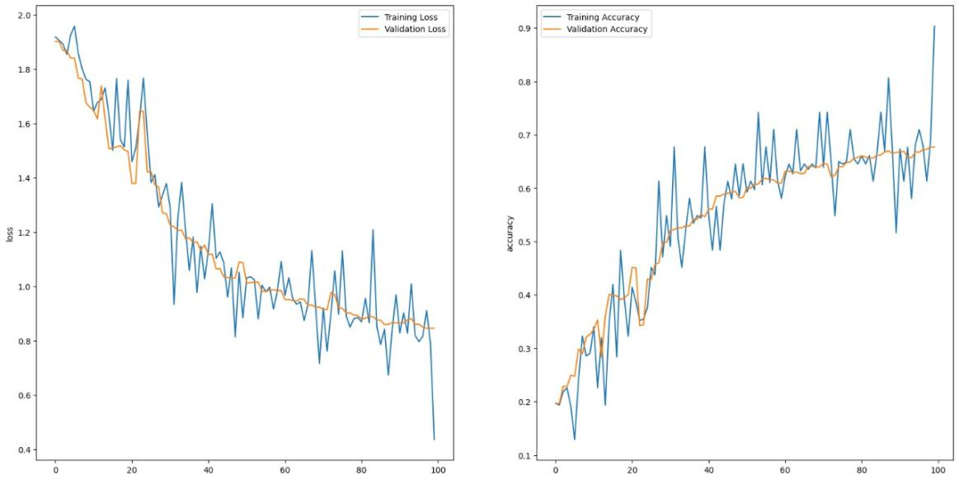
Fig.6.1 LSTM model

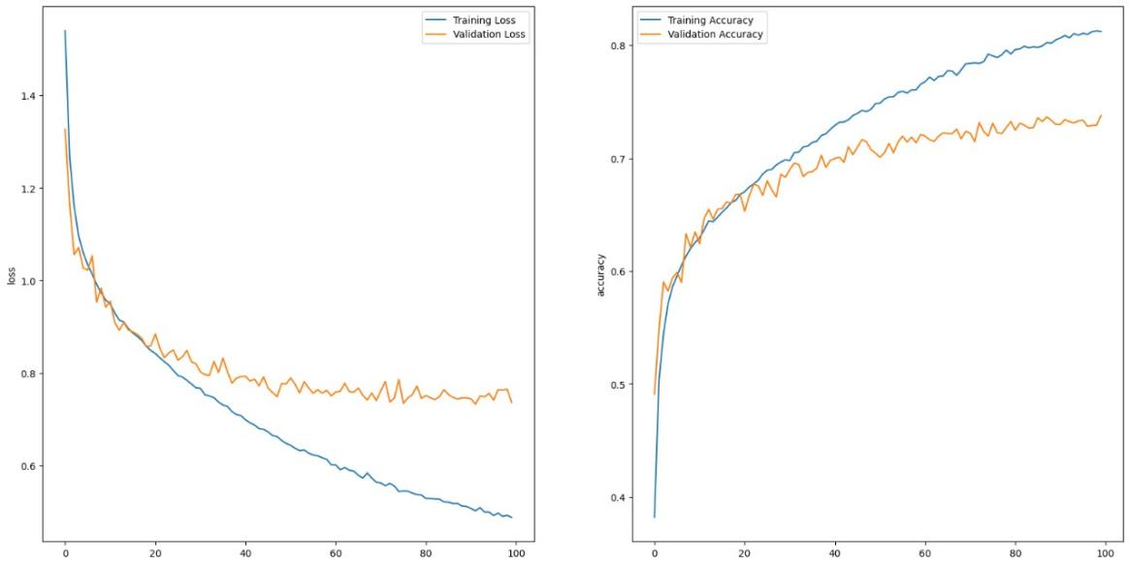
Fig.6.2 CNN-LSTM model
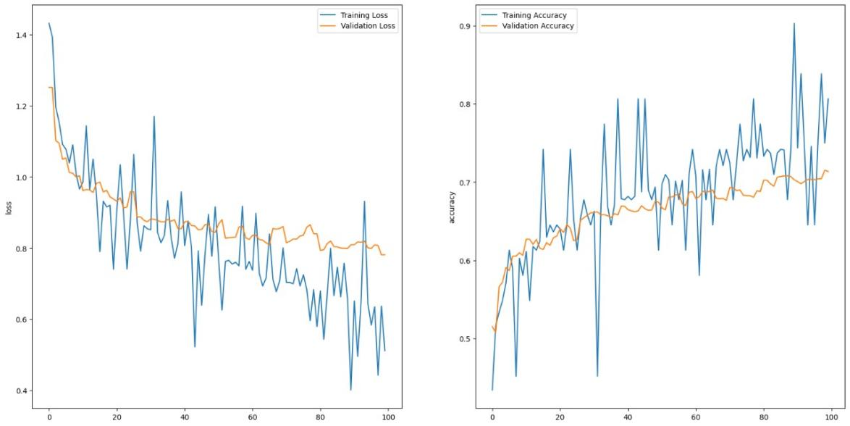
Fig.6.3 ANN model
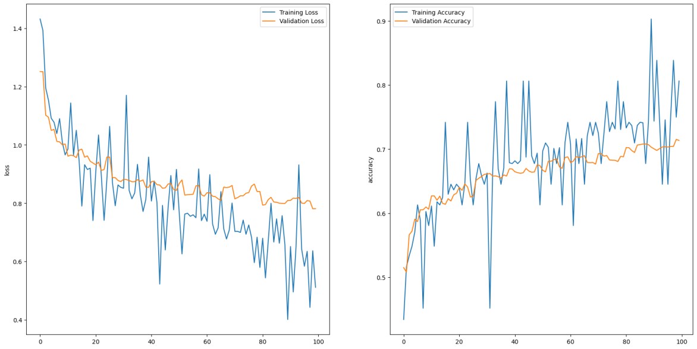

PREDICTION OUTPUT:

array([[0.12231044, 0.00413417, 0.10876969, 0.7255662 , 0.01023937,
0.0020535 , 0.02692665]], dtype=float32)

REFERENCE
- S. R. Livingstone and F. A. Russo, “The Ryerson Audio-Visual Database of Emotional Speech and Song (RAVDESS),” PLOS ONE, vol. 13, no. 5, pp. 1–35, 2018.
- M. G. Koolagudi and K. S. Rao, “Emotion recognition from speech: a review,” International Journal of Speech Technology, vol. 15, no. 2, pp. 99–117, 2012.
- P. Tzirakis et al., “End-to-end speech emotion recognition using deep neural networks,” IEEE J. Sel. Topics Signal Process., vol. 11, no. 8, pp. 1301–1309, 2017.
- Y. LeCun, Y. Bengio, and G. Hinton, “Deep learning,” Nature, vol. 521, no. 7553, pp. 436–444, 2015.
- H. Fayek, M. Lech, and L. Cavedon, “Evaluating deep learning architectures for Speech Emotion Recognition,” Neural Networks, vol. 92, pp. 60–68, 2017.
- Z. Zhang, B. Wu, and B. Schuller, “Attention-augmented end-to-end multi-task learning for emotion prediction from speech,” IEEE Transactions on Affective Computing, vol. 13, no. 4, pp. 2049–2061, 2022.
- S. Latif, R. Rana, S. Khalifa, R. Jurdak, J. Epps, and B. W. Schuller, “Survey of deep learning techniques for speech emotion recognition,” IEEE Transactions on Affective Computing, vol. 14, no. 3, pp. 1634–1653, 2023.
- D. Ververidis and C. Kotropoulos, “Emotional speech recognition: Resources, features, and methods,” Speech Communication, vol. 48, no. 9, pp. 1162–1181, 2006.
- T. Li, X. Dai, and Y. Li, “Speech emotion recognition using convolutional recurrent neural networks with attention mechanism,” IEEE Access, vol. 7, pp. 94398–94410, 2019.
- C. N. Anagnostopoulos, T. Iliou, and I. Giannoukos, “Features and classifiers for emotion recognition from speech: A survey from 2000 to 2011,” Artificial Intelligence Review, vol. 43, no. 2, pp. 155–177, 2015.

